Architecture Design

Heart Disease Diagnostic Analysis

Revision Number: 1.0

Last date of revision: 26/08/2021

Shrey Shah

**Document Version Control**

|  |  |  |  |
| --- | --- | --- | --- |
| **Date Issued** | **Version** | **Description** | **Author** |
| 26th August, 2021 | 1.0 | Initial Draft of ADD | Shrey Shah |
|  |  |  |  |
|  |  |  |  |
|  |  |  |  |

**Contents**

Document Version Control**2**

1 Introduction**4**

1.1 Purpose4

1.2 Scope4

1.3 Intended Audience4

1.4 Acronyms and Definitions4

2 Architecture Description**5**

2.1 Tableau Server Architecture5

2.1.1 Gateway / Load Balance5

2.1.2 Application Server6

2.1.3 VizQL Server6

2.1.4 Data Engine7

2.1.5 Backgrounder6

2.1.6 Data Server6

2.1.7 Tableau Communication Flow7

3 Deployment**7**

3.1 Deployment options7

3.2 Single Node Architecture8

3.3 Two Node Architecture9

3.4 Five Node Architecture 10

1. **Introduction**

**1.1 Purpose**

The purpose of this Architecture Design Document (ADD) is document provides a comprehensive architectural overview of the system, using a number of different architectural views to depict different aspects of the system. It is intended to capture and convey the significant architectural decisions which have been made on the system.

A software architecture document is a map of the software. We use it to see, at a glance, how the software is structured. It helps you understand the software’s modules and components without digging into the code. It is a tool to communicate with others—developers and non-developers—about the software. It provides a comprehensive architectural overview of the system. It is intended to capture and convey the architectural strategies which have been made.

The ADD will cover the following aspects:

1. Describe the architecture of the Tableau system used in detail.
2. Present the communication flow in Tableau server.
3. Elaborate the different Deployment strategies of Tableau.

**1.4 Scope**

The ADD documentation applies to each static and dynamic aspect of the system. Under the static and dynamic behaviour of the system, the document describes the use case realizations.

**1.3 Intended Audience**

The ADD document can be used as a reference by the following categories of people.

1. Design Team
2. Development Team
3. Operations Team

**1.4 Acronyms and Definitions**

This sub - section includes the definitions of all acronyms required to interpret the ADD properly

|  |  |  |
| --- | --- | --- |
| **Sr. No.** | **Acronym** | **Definition** |
| 1. | ADD | Architecture Design Document |

1. **Architecture Description**

**2.1 Tableau Server Architecture**

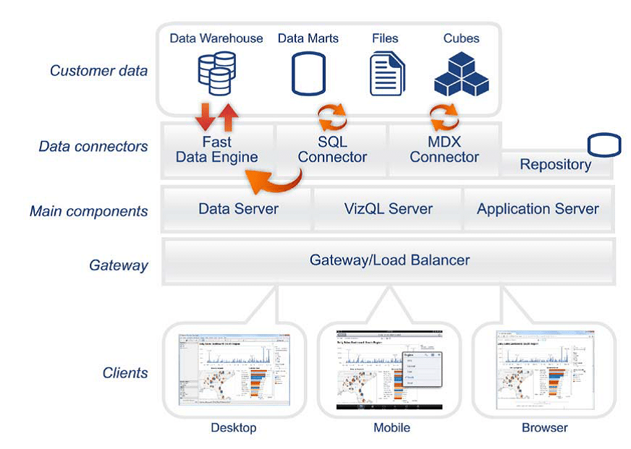

Fig. 1 – Tableau Server Architecture

Fig. 1 shows the architecture of the Tableau Server. It consists of the following components:

* + 1. **Gateway/Load Balancer:**

It acts as an Entry gate to the Tableau Server and also balances the load to the Server if multiple Processes are configured.

**2.1.2 Application Server:**

Application Server processes (wgserver.exe) handle browsing and permissions for the Tableau Server web and mobile interfaces. When a user opens a view in a client device, that user starts a session on Tableau Server. This means that an Application Server thread starts and checks the permissions for that user and that view.

* + 1. **Repository:**

Tableau Server Repository is a PostgreSQL database that stores server data. This data includes information about Tableau Server users, groups and group assignments, permissions, projects, data sources, and extract metadata and refresh information.

* + 1. **VizQL Server:**

Once a view is opened, the client sends a request to the VizQL process (vizqlserver.exe). The VizQL process then sends queries directly to the data source, returning a result set that is rendered as images and presented to the user. Each VizQL Server has its own cache that can be shared across multiple users

* + 1. **Data Engine:**

It Stores data extracts and answers queries.

* + 1. **Backgrounder:**

The backgrounder Executes server tasks which includes refreshes scheduled extracts, tasks initiated from tabcmd and manages other background tasks.

* + 1. **Data Server:**

Data Server Manages connections to Tableau Server data sources It also maintains metadata from Tableau Desktop, such as calculations, definitions, and groups.

* + 1. **Tableau Communication Flow**

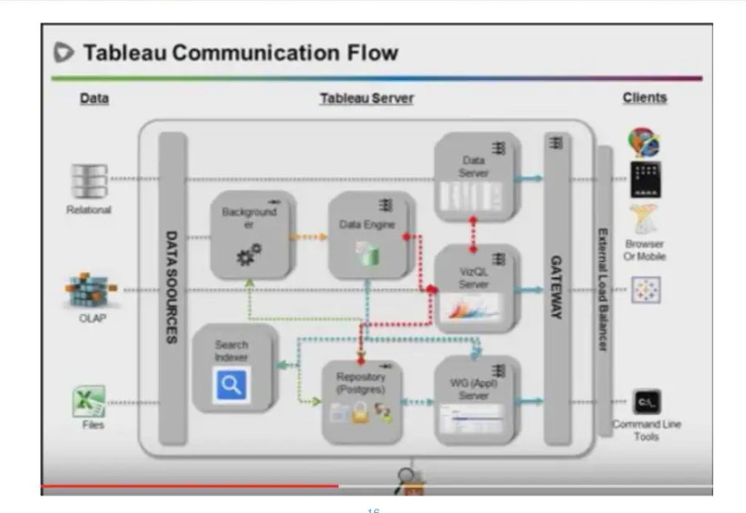

**3 Deployment**

**3.1 Deployment Options**

Tableau’s analytics platform offers three different deployment options depending on your environment and needs. The below graphic shows each option at a glance:

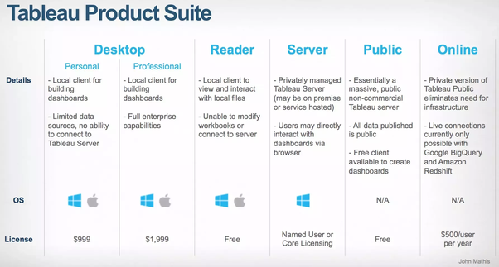

1. Tableau Online Get up and running quickly with no hardware required. Tableau Online is fully hosted by Tableau so all upgrades and maintenance are automatically managed for you.
2. Tableau Server deployed on public cloud: Leverage the flexibility and scalability of cloud infrastructure without giving up control. Deploy to Amazon Web Services, Google Cloud Platform, or Microsoft Azure infrastructure to quickly get started with Tableau Server (on your choice of Windows or Linux). Bring your own license or purchase on your preferred marketplace.
3. Tableau Server deployed on-premises: Manage and scale your own hardware and software (whether Windows or Linux) as needed. Customize your deployment as you see fit.
   1. **Single Node Architecture**

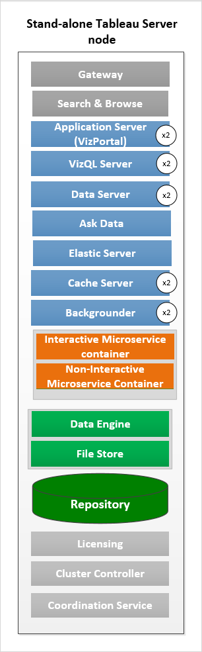

This architecture is a single node architecture. This is the most simple deployment topology. This type of installation is reasonable for testing, running trials, and for environments that can handle occasional downtime and system availability due to lack of redundancy. All server processes are running on a single machine. There is less redundancy and fewer safeguards in the event of a problem with one of the server processes. You also need to make sure the computer you install Tableau Server on has adequate resources to handle the processes and the demands of users and data.

* 1. **Two Node Architecture**

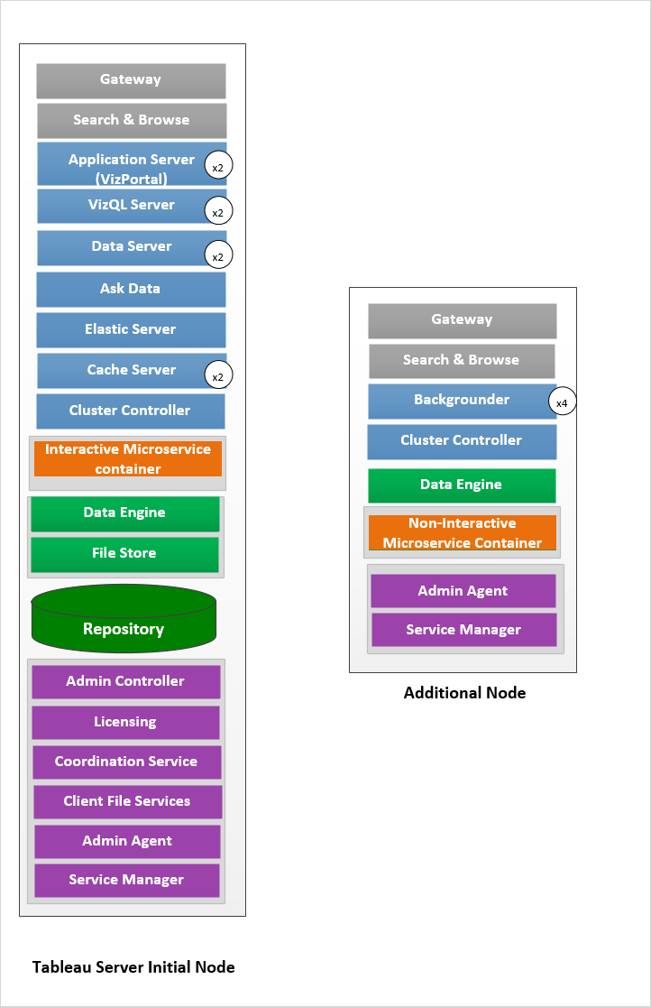

This architecture is a 3 Node Architecture which is more capable to handle concurrent requests.

If we need failover or high availability, or want a second instance of the repository, we must install Tableau Server on a cluster of at least three computers. In a cluster that includes at least three nodes, you can configure two instances of the repository, which gives our cluster failover capability.

* Extract heavy environment
* Frequent extract refreshes
  1. **Five Node Architecture (Highly Available)**

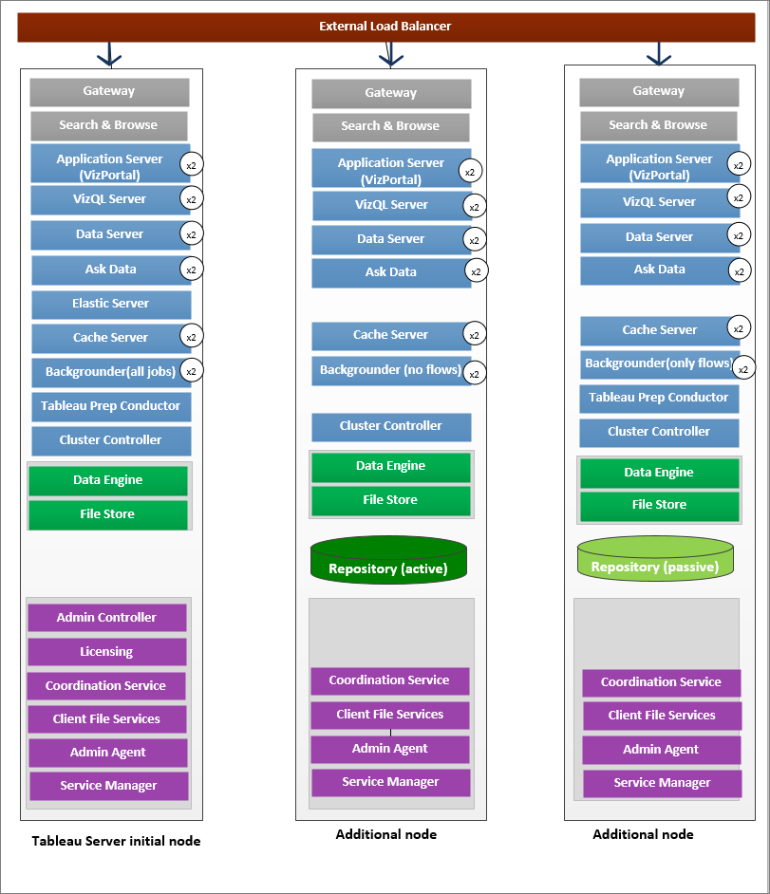

An HA installation of Tableau Server is a special type of multi-node installation with a minimum of three nodes and multiple instances of key processes (the Repository, File Store/Data Engine (Hyper), Coordination Service, and Client File Service) on different computers. With an HA installation, there is built-in redundancy of those key processes, including multiple File Stores, and automatic Repository failover. The goal is to minimize system downtime by eliminating single points of failure, and enabling detection of failures with failover where possible.

Downtime is still possible, in the event of an initial node failure. Dashboards and views may load more slowly than expected, and timeouts are possible, depending on how your system is configured and being used.